**Practical Answers 5 – Open Root Finding Methods**

Plotting the function is a good idea to get an idea of where the roots are and provide initial guesses, then the methods can be used to get an accurate estimation.   
You can also substitute your answers back into the equation to see if it is correct (anonymous functions can help with that).

1. Use the **roots** function to find the roots of the polynomial.  
     
    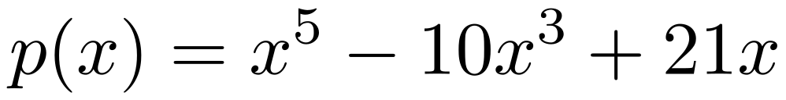
2. Create an anonymous function for p(x) and substitute the roots you found in question 1 into it to verify your answer.

|  |
| --- |

1. Use the **roots** function to find the roots of the polynomial (no template). Display only the real roots.  
     
    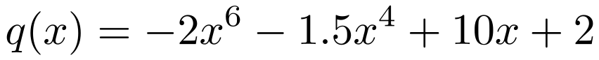

|  |
| --- |

1. Use the **fzero** function to locate all roots of   
     
    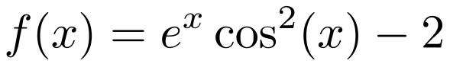  
     
   on the interval [0,5]. Plot the function with a grid and mark the roots with large green diamonds. For this question make a function file to hold the function. You will have to divide the interval into pieces using an appropriate step size, h. First try   
   h = 2, then plot the function and roots to see if it found them all. If not, adjust your value of h and try again.

| With h = 2:    With h = 1: |
| --- |

1. Write a script that solves   
     
    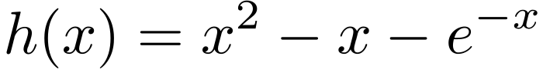  
     
   using Fixed Point Iteration. Choose your own stopping criteria and keep track of the error at each iteration. Keep in mind that you can choose any of the following 4 formulas for your fixed point iteration:  
     
    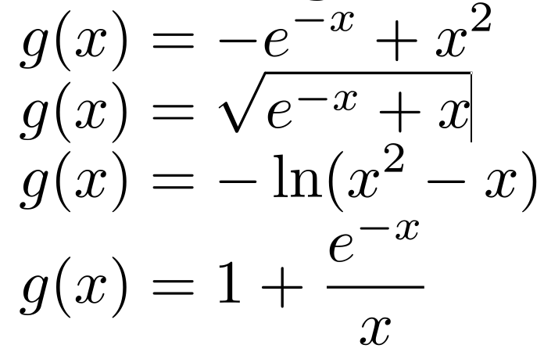  
   Test all of them to see which work and which don’t.

| I used x = 1 as my initial guess with a tolerance of 0.0001.  Formula 1:  Formula 2:    Formula 3:    Formula 4: |
| --- |

1. Write a function that takes an initial guess as input then locates a root of   
     
    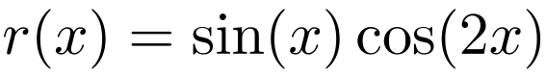  
     
   using the Newton-Raphson Method. Remember you will have to differentiate the function to get the formula. Choose your own convergence criterion.

| When x0 = 1:    When x0 = 5: |
| --- |

1. Use your function from question 7 to find all roots of r(x) on the interval [–π,π].

| When I used 100 values between –π and π I got: |
| --- |

1. Write a script that locates all roots of   
     
    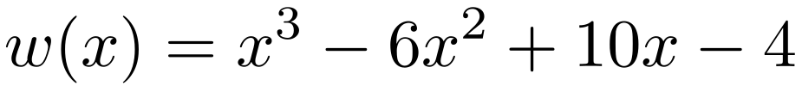  
     
   using the Bisection Method. Locate brackets by using the incremental search method you wrote before.

| Note below I checked whether an exact root was found by the incremental search method first instead of wasting computation time on the Bisection method where unneeded. |
| --- |

1. The volume of liquid V in a hollow horizontal cylinder of radius r and length L is related to the depth of the liquid h by,  
     
    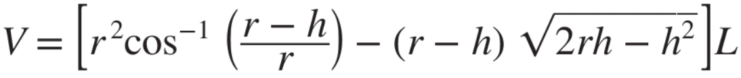  
   Determine *h* given *r* = 2m, *L* = 5m, and *V* = 8m.

|  |
| --- |

1. Determine the location of the horizontal tangents (turning points) of  
     
    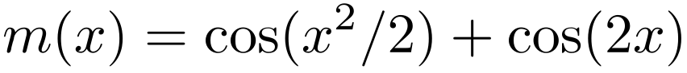  
     
   on the interval [–π,π]. Plot the figure and mark the turning points with thick, large red circles with blue faces .

|  |
| --- |